**JUnit Testing Exercises**

**Exercise 1: Setting Up Junit**

package test;

import org.junit.Test;

import static org.junit.Assert.*;

public class Sample {

@Test

public void testAddition() {

int sum = 2 + 3;

*assertEquals*(5, sum);

}

}

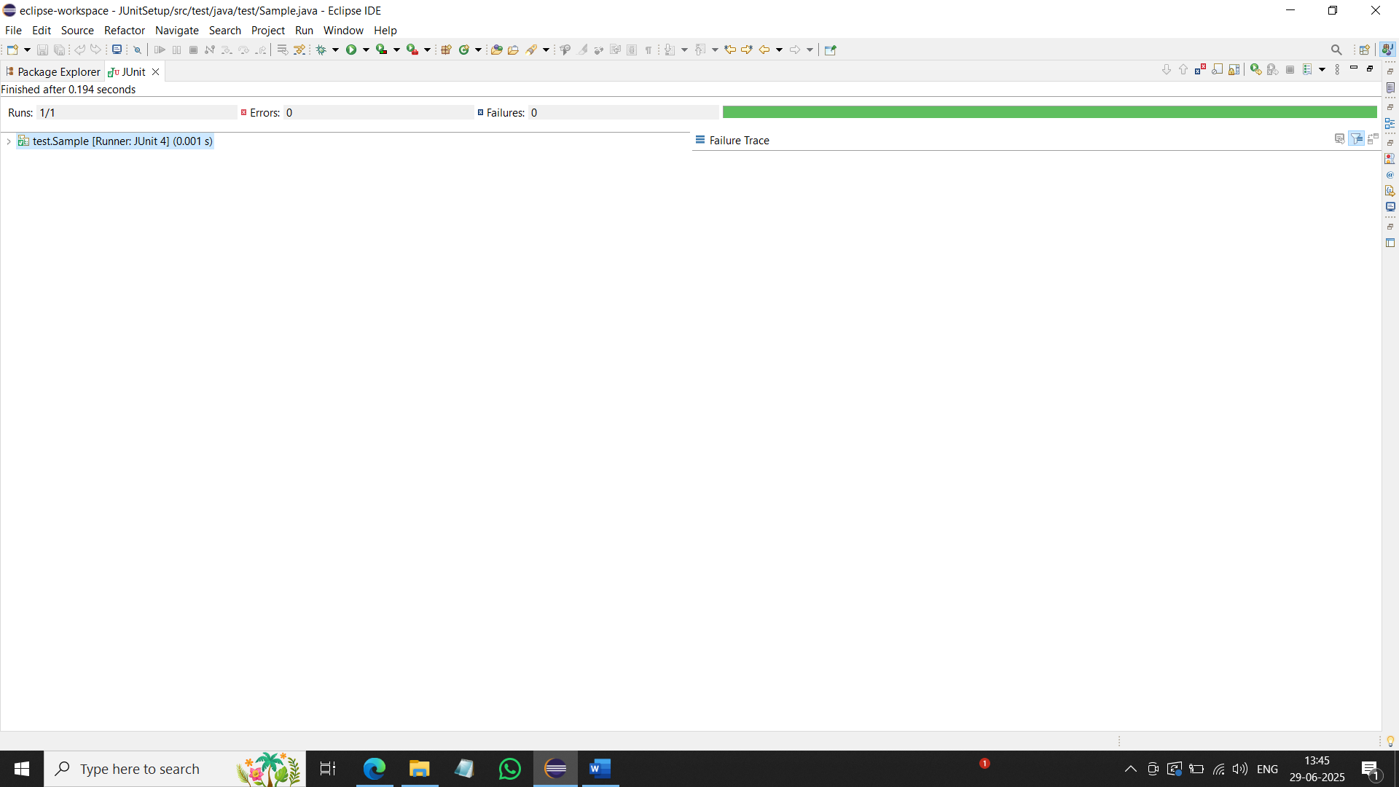

**Exercise 3: Assertions in Junit**

package test;

import org.junit.Test;

import static org.junit.Assert.*;

public class AssertionsTest {

@Test

public void testAssertions() {

*assertEquals*(5, 2 + 3);

*assertTrue*(5 > 3);

*assertFalse*(5 < 3);

*assertNull*(null);

*assertNotNull*(new Object());

}

}

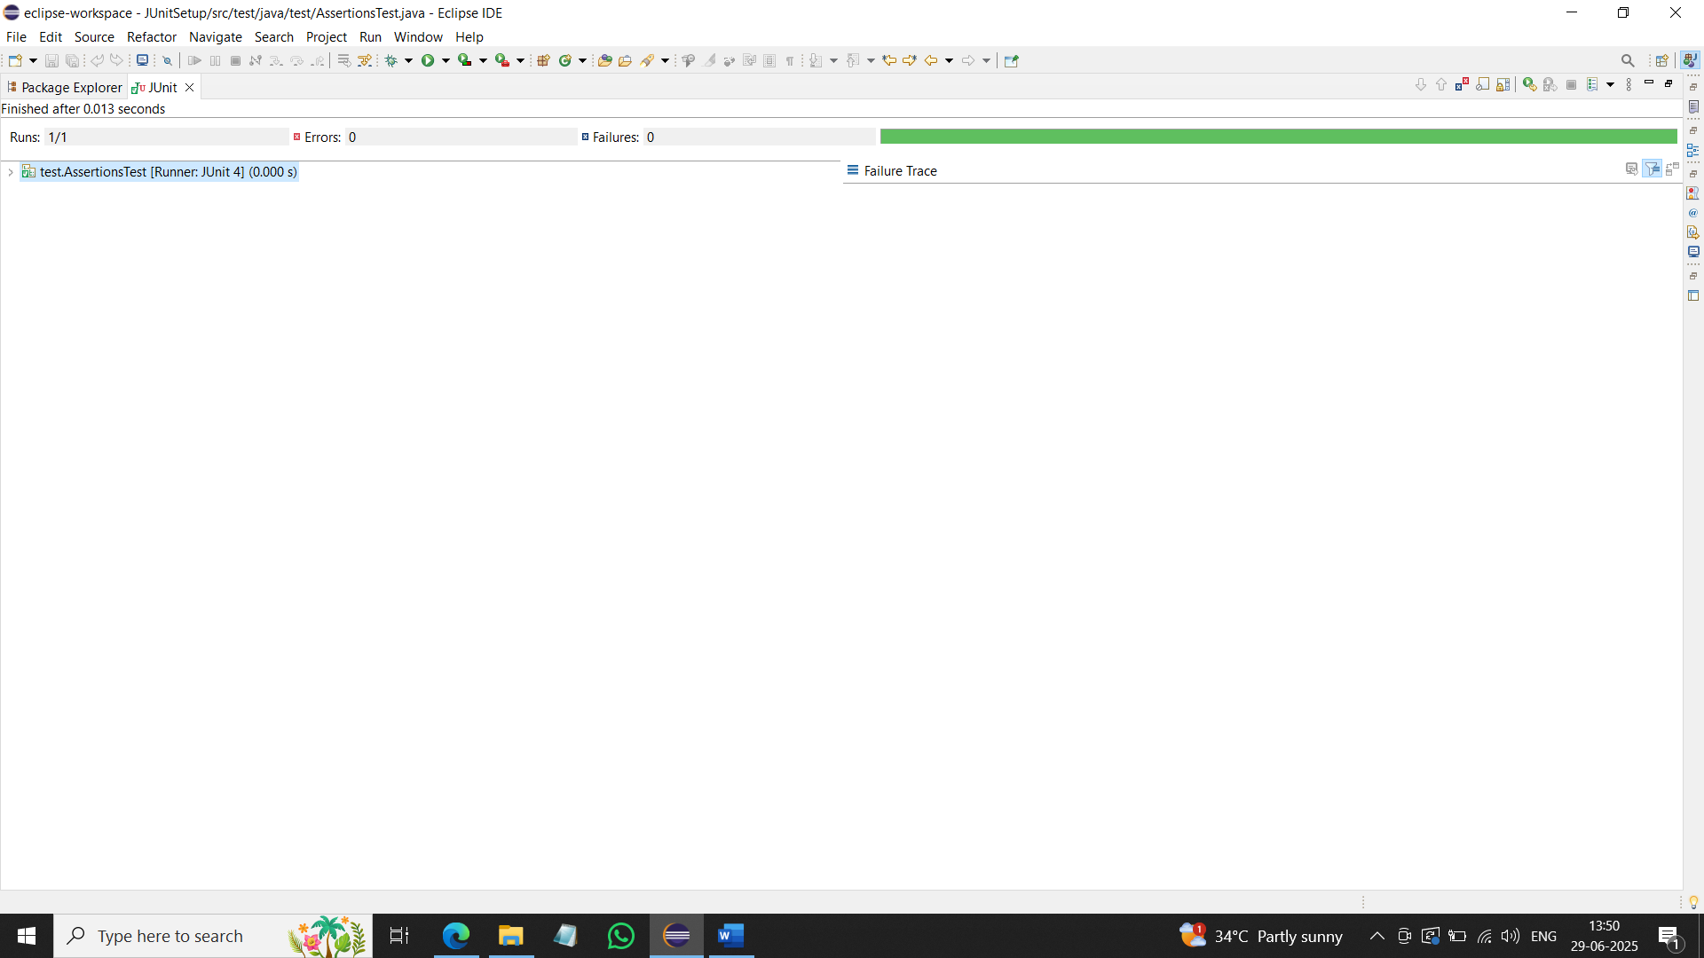

**Exercise 4: Arrange-Act-Assert (AAA) Pattern, Test Fixtures, Setup and Teardown Methods in JUnit**

**Calculator.java:**

package junit;

public class Calculator {

public int add(int a, int b) {

return a + b;

}

public void close() {

System.*out*.println("Calculator closed.");

}

}

**CalculatorTest.java:**

package test;

import junit.Calculator;

import org.junit.Before;

import org.junit.After;

import org.junit.Test;

import static org.junit.Assert.*;

public class CalculatorTest {

private Calculator calculator;

@Before

public void setUp() {

calculator = new Calculator();

System.*out*.println("Setup: Calculator created.");

}

@After

public void tearDown() {

calculator.close();

System.*out*.println("Teardown: Calculator closed.");

}

@Test

public void testAddition() {

int a = 2;

int b = 3;

int result = calculator.add(a, b);

*assertEquals*(5, result);

}

}

